 

**Technical Training Module**

**Project Report**

**On**

**Restaurant Management System**

**Using**

**Python Programming Language**

**Submitted by:**

**VIKASH KUMAR**

**MD SAQLAIN MANSOOR**

**C.S.E. (4th sem)**

**Submitted To:**

**Mr. Rajat Tyagi sir**

**(Mentor – CETPA InfoTech Ltd.)**

**Mr. Satendra Kumar**

**(H.O.D – CSE Deptt. – Quantum School of Technology, Roorkee )**

**ACKNOWLEDGEMENT**

First of all we are very thankful to our prestigious college Quantum School of technology, for bringing this great training in our reach for learning, moreover we would also like to express our gratitude towards cetpa InfoTech for their training and guidance in python programming language. Last but not the least we would also like to thank our trainers for teaching us in a friendly and amazing manner (with no doubt that we not only learned but also enjoyed a lot in the training sessions).

**Student name:**

Vikash Kumar & Md Saqlain Mansoor

**Submitted to:**

Mr. Rajat Tyagi

Mr. Satendra Kumar

**PROJECT TOPIC:**

**RESTURANT MANAGMENT SYSTEM**

**Content**

**1.INTRODUCTION**

1.1. Objective

**2. PROJECT DESCRIPTION**

2.1. Problem Definition

2.2. Problem Analysis

2.3. Solution for problem

2.4. Module Description

2.5. Output

2.6. Data Flow Diagram

**3.CONCLUSIONS AND FUTURE ENHANCEMENT**  3.1. Reference 3.2. Conclusion

**Introduction**

The main objective of this project is to develop a client/hotel model, which deals with “Restaurant Management System”. The system has a complete part for manager or receptionist and the billing system.

The customer side allows the customer to view menu/price list according to the delivery he desires and reserve meal for that specific time.

**Problem definition:**

Restaurant is a kind of business that serves people all over world with ready-made food. Currently this industry is going on with lot of flare. People feel more comfortable with lot of variations in the selection and consumption of their food in their busy life.

One can see lot more restaurant in the world. Even in Denmark one can see thousands of restaurants with dishes from all over the world like from India, Pakistan, Mexican, etc fulfilling the needs of people with nourishments and enjoyments.

Let’s concentrate on booking area in a restaurant. In traditional booking system, a customer has to make a phone call in order to get his meal reserved. If luckily the phone gets connected, then the customer does some formal conversation like hello, hi, etc. Than he demands for today’s menu and do some discussion over menu items then he orders and he has to give some of this identification specifications. This process takes 5-8 minutes to complete. On the receiver side there is hardly one phone line and one operator. So he can cover around 15-20 orders maximum in an hour.

For each booking he has to register manually on paper and puts the order in a queue with specific priority according to time and quantity, and than a cook is assigned for the specific order to complete it.

There are lots of areas to be solved for current restaurants using modern IT World. Many areas come like human resource management, accounts management, etc. But our problem lies within domain of end customer and restaurant “Meal Reservation”.

**Problem Analysis:**

As discussed earlier our main problem area focuses on the “Meal reservation/booking system”, there are lot of problems in that area which are associated with both the customer and the restaurant staff.

We would like to analyze some of the problems here:

**a.** Initial problem is that the customer has to get connected over the phone, it would be harder if the restaurant is very popular and busy.

**b**. As customer won’t have the menu list with him, it would be harder for him to remember the entire list (with price as well...!) and come to a decision, i.e. customer is provided with less time to make decision.

**c**. The chances of committing mistakes at the restaurant side in providing a menu list for a specific time would be more.

**d**. There might be some communication problems or sometimes language might be a barrier.

**e**. As entire booking has to be done manually at the restaurant end, the chances of occurrence of mistakes is high as well.

**f**. Most of restaurants have single phone line and a single operator to handle incoming calls, so they can accept limited orders.

**g**. If the restaurant is of busy type, than the operator is left with no time to decide over the priority of the order fulfillment.

**h**. Even assigning orders (or some menu from the order) to a specific cook can be cumbersome if it is done parallel with the bookings of the order.

**i**. All the calls will not by intended for booking, as some calls might be for canceling the order or to fetch the status as well, this eats up the productive time at the restaurant side.

Still there might be many other problems associated with the traditional system of booking through telephone. So what should be the solution for these problems...?

**Solutions for the Problems**

The solution for the above problems, so far we have thought, is client-server system that listen the requests online. We have the intensions to make the system that takes the customer reservations through the browser.

But how to make it?

To resister a meal online, the customer has to become a member first then he can access the later part of the site. The option of becoming member was only an attempt to avoid (to some extent) placing the fake bookings.

according to price range and category of food and later customer can order a meal.

Customer can cancel food order if they wish to.

**MODULE DISCRIPTION**

No Library files are required in this project as less complexity occurs.

**Usage:**

from tkinter import*

import random

import time

**Time & Date**

Time is needed to be imported to view time.

We can also use "import date" to view/show date.

Tkinter:

**Tkinter** is a python binding to the Tk GUI toolkit. It is the standard Python interface to the Tk GUI toolkit and is Python's de facto standard GUI. Tkinter is included with standard LINUX, Microsoft and Mac OS X installs of Python.

The name *Tkinter* comes from *Tk interface*. Tkinter was written by Fredrik Lundh.

Tkinter is free software released under a Python license.

**Output**

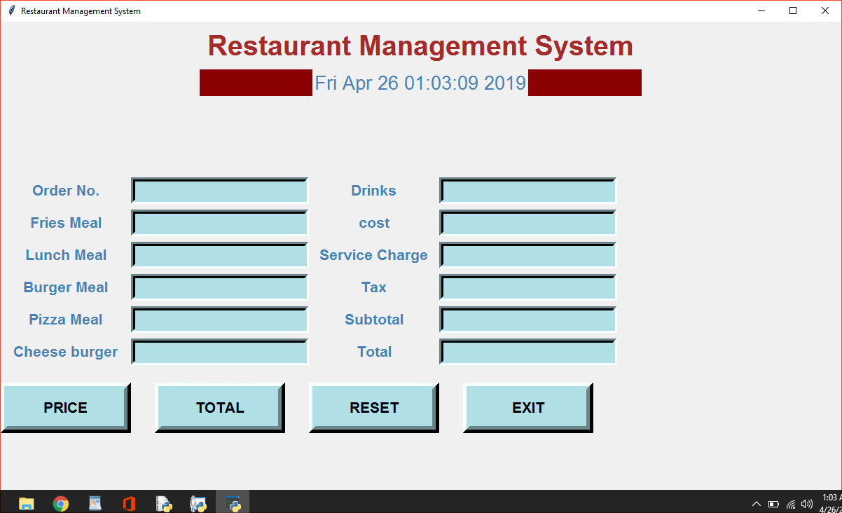

**Data Flow Diagram**

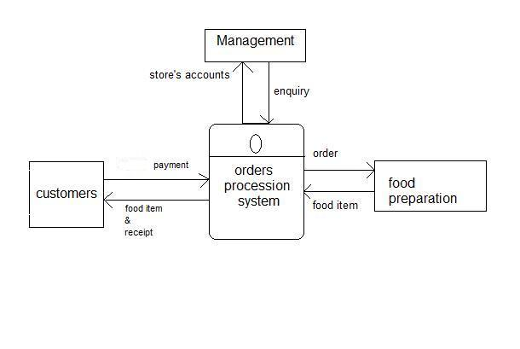

**REFERENCES:**

The internet helped me in making this program and all the knowledge

Provided in our training program.

I took a help from some YouTube videos

Link:

<https://www.youtube.com/watch?v=hqC9tioGCi0>

**CONCLUSION:**

With this project of ours we intend to get the full usage of Tkinter and its works. We also eye in developing new ideas relating us with the new and advent technologies of this growing world.

We worked in team to develop this which ensured our teaming ability, coordination with each other and respecting each other that ultimately helps in developing good Boethius before going on the industrial level.

THANK YOU